Name____________________________________ Period_____

English 10 Mrs. Filor

Marking Period 2

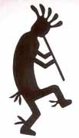Kokopelli

Mythology Reading Ladder

Credit______/50

**Mythology Lecture Notes**

1.  Definition of Mythology

Mythology—

  a myth is one story in a mythology—a system of hereditary stories which were once believed to be true by a particular cultural group, and which served to explain (in terms of the intentions and actions of gods and other supernatural beings) why the world is as it is and things happen as they do, to provide a rationale for social customs and observances, and to establish the sanctions for the rules by which people conduct their lives.

2.  Different Types of myths

hero—tell about the exploits of a hero who may or may not be divine

god—establish and tell about the exploits of the gods/goddesses

creation—explain how the world was created

fertility—explain the growth of people and foods

3.  Common Elements Found in a Myth

·        the crisis

·        the hero of divine birth

·        the monster

·        the advice giver

·        the magical (symbolic) gift

·        the journey

·        the helper

·        the fight

·        the return

·        gods

·        an explanation for why things are

4.  List three cultures from which you are interested in reading mythology:

Date_____

Rung One

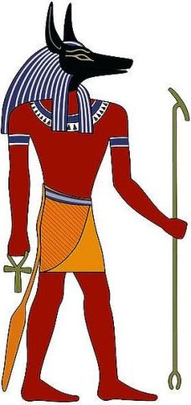Annubis

Title of Myth (Choose any myth from *World Mythology*.)_______________________

Culture of Myth_____________________________________________________________

Kind of Myth________________________________________________________________

Page numbers of Myth: __________-__________

Summarize Myth Below (Include what happened in the beginning, middle and end):

___________________________________________________________________________________________________________________________________________________________________________________________________________________________________________________________________________________________________________________________________________________________________________________________________________________________________________________________________________________________________________________________________________________________

_____________________________________________________________________________

What are some myth elements in this story?  Give an example._______________

_____________________________________________________________________________

_____________________________________________________________________________What can you tell this culture values based on this myth?  A value is an important ideal._____________________________________________________________

_____________________________________________________________________________

_____________________________________________________________________________                                                                                                                    Credit Earned______

Date_____

Rung Two

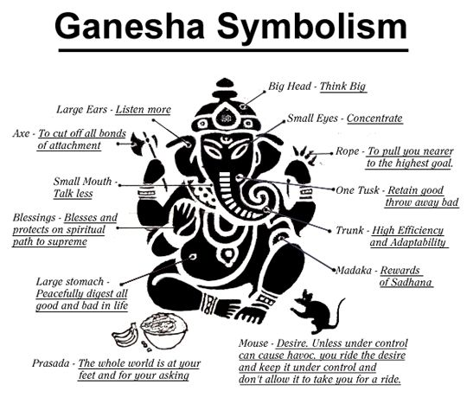

Title of Myth (Choose any myth from *World Mythology*.)_______________________

Culture of Myth_____________________________________________________________

Kind of Myth________________________________________________________________

Page numbers of Myth: __________-__________

Summarize Myth Below (Include what happened in the beginning, middle and end):

_______________________________________________________________________________________________________________________________________________________________________________________________________________________________________________________________________________________________________________________________________________________________________________________________________________________________________________________________________________________________________________________________________________________________________________________________________________________________________________________________________________________________________________________________________________________________________________________________________________________________________________________________________________

_____________________________________________________________________________

What are some myth elements in this story?  Give an example._______________

_____________________________________________________________________________

_____________________________________________________________________________

What can you tell this culture values based on this myth?  A value is an important ideal._____________________________________________________________

_____________________________________________________________________________

_____________________________________________________________________________                                                                                                                    Credit Earned______

Date_____

Rung Three

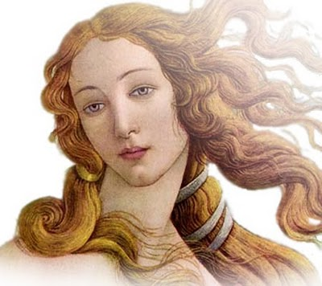Venus

Title of Greek Myth (Choose a Greek myth from *Heroes, Gods and Monsters of*

*the Greek Myths*.)____________________________________________________________

Kind of Myth________________________________________________________________

Page numbers of Myth: __________-__________

Summarize Myth Below (Include what happened in the beginning, middle and end):

_______________________________________________________________________________________________________________________________________________________________________________________________________________________________________________________________________________________________________________________________________________________________________________________________________________________________________________________________________________________________________________________________________________________________________________________________________________________________________________________________________________________________________________________________________________________________________________________________________________________________________________________________________________

What are some myth elements in this story?  Give an example._______________

_____________________________________________________________________________

_____________________________________________________________________________What can you tell Greek culture values based on this myth?  A value is an important ideal._____________________________________________________________

__________________________________________________________________________________________________________________________________________________________

                                                                                                                     Credit Earned______

Date_____

Rung Four

Comparing Myths: Choose two myths of the same type (creation, god, hero, fertility) from **two** different cultures that you **haven’t read** yet to compare below.

Credit Earned ______

Date_____

Rung Five

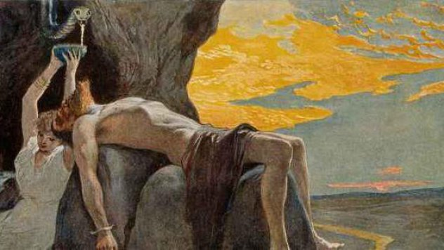Loki

How many myths did you read this marking period?__________________________

What else did you read this marking period?_________________________________

_____________________________________________________________________________

_____________________________________________________________________________

How many pages did you read this marking period?__________________________

How many pages on average per week did you read?__________________________

Text Study: How does literature shape and enhance our understanding of the cultures of others?  What did you learn from reading these myths? Give examples.

________________________________________________________________________________________________________________________________________________________________________________________________________________________________________________________________________________________________________________________________________________________________________________________________________________________________________________________________________________________________________________________________________________________________________________________________________________________________________How do you feel about your reading progress?  What reading goals do you have for next marking period?_______________________________________________

_______________________________________________________________________________________________________________________________________________________________________________________________________________________________________

What myth will you use as the basis of your research project?________________

_____________________________________________________________________________

Credit Earned ______