PLANT STRUCTURE

* Plants are organisms….. This makes them a LIVING THING.
* They have cells. (main structures: cell wall, large vacuole, chloroplast)
* They are the base of a food chain.
* They make their own food. They use the process of PHOTOSYNTHESIS.
* Words to look for- autotroph, producers, photosynthetic.

3 Main Parts

1. Roots- Holds plants in soil and takes up water and minerals from the soil.

2. Stem- Holds the plant upright and expands the leaves

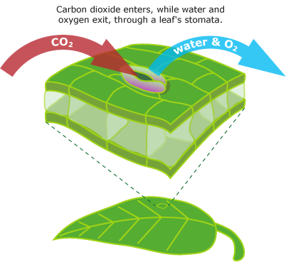 A plant has vascular tissue (VEINS)

a. Xylem: Carries water throughout the plant

b. Phloem: Transports food (glucose)

3. Leaves- Captures sunlight…… Site of photosynthesis

1. Cuticle- Shiny waxy layer that prevents water loss

2. Stomates- tiny holes in the underside of a leaf that allows for gas (O2/CO2) exchange and transpiration or water loss.

3. Guard cells- Regulate the opening and closing of a stomate.

a Decrease in water in the environment====== the stomates close to prevent water loss

Increase in water in the environment======= the stomates are opened.

Describe the job of a guard cell- Circle one

1. During a drought in the summer. OPEN CLOSED
2. In a plant in a rainforeset. OPEN CLOSED

PLANT STRUCTURE

* Plants are ____________….. This makes them a ________________________________.
* They have cells. (main structures: ____________, large vacuole, __________________)
* They are the _______________ of a ______________________ ________________.
* They make their own food. They use the process of ____________________________.
* Words to look for- ___________________, producers, photosynthetic.

3 Main Parts

1. _________- Holds plants in soil and takes up water and minerals from the soil.

2. Stem- Holds the plant upright and expands the leaves

 A plant has vascular tissue (VEINS)

a. ___________: Carries water throughout the plant

b. __________________: Transports food (glucose)

3. Leaves- Captures sunlight…… Site of photosynthesis

1. _______________- Shiny waxy layer that prevents water loss

2. Stomates- tiny holes in the underside of a leaf that allows for gas (_____/____) exchange and transpiration or water loss.

3. _________________- Regulate the opening and closing of a stomate.

_______________ in water in the environment====== the stomates close to prevent water loss

__________________in water in the environment======= the stomates are opened.

Describe the job of a guard cell- Circle one

1. During a drought in the summer. OPEN CLOSED

In a plant in a rainforeset. OPEN CLOSED