**The Mongol Conquests**

***The greatest happiness is to scatter your enemy.***

***to drive him before you, to see his cities reduced to ashes,***

***to see those who love him shrouded in tears,***

***and to gather into your bosom his wives and daughters. – Genghis Khan***

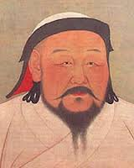**The Mongols built the largest unified land empire in world history.**

**While the Chinese prospered during the Song Dynasty ( 960-2179) the Mongol people to the north were gaining strength.**

**Nomads of the Asian steppe.**

**Dry grassland across the land mass of Eurasia.**

**Little rain, dry, wind-swept plain, short hardy grasses. Temperature extremes -57F in winter to 96F in the summer.**

**It served as a land trade route connecting the East and the West.**

**Home to nomadic peoples who frequently swept into the cities to plunder, loot, and conquer.**

**Nomadic way of life:**

**Pastoralists—they herded domesticated animals.**

**Constantly on the move searching for good pasture to feed herds.**

**Followed a familiar seasonal pattern and retuned on a regular basis to the same campsites.**

**Battles frequently arose among nomadic groups over grassland and water rights.**

**Practically lived on horseback.**

**Traveled together in kinship groups called clans.**

**The Rise of the Mongols**

**Around 1200, a Mongol khan or clan leader, named Temujin wanted to unify the clans under his leadership.**

**Accepts the title Genghis Khan or universal ruler of the Mongol clans.**

**His first goal was China**

**West Mongolia destroyed one city after another by 1221 Central Asia was under Mongol country.**

**Genghis the Conqueror**

**Brilliant organizer**

**Armies of 10,000 1,000 men brigades, 100 men companies and 10 men platoon.**

**Gifted strategist**

**Used tricks to confuse his enemy. Sometimes a small Mongol Calvary unit would attack then pretend to gallop away in flight. Enemy usually gave chase then rest of the Mongol army would appear and slaughter enemy forces.**

**Make the enemy believe that the Mongol army was bigger than it actually was. This was done by dressing prisoners or lifelike dummies as Mongol warriors.**

**The use of spies to find out enemy weaknesses.**

**Adopted new weapons and technologies used by his enemies.**

**He put captured Chinese engineers to work building catapults and creating gunpowder charges.**

**Used cruelty as a weapon**

**If a city refused to open its gates to him, he might kill the entire population**

**Terror inspired many towns to surrender without a fight.**

**The death of Genghis Khan dies in 1227 and the khanates**

**His son becomes the Great Khan drove armies south, east and west out of Inner Asia.**

**Completed conquest of northern China and invaded Korea**

**Leveled the Russian city of Kiev reached the banks of the Adriatic Sea.**

**Cities of Vienna and Venice in their grasp**

**Son dies, commanders called back to their capital to elect his successor. Westward campaign ended.**

**By 1260 the Mongol Empire was divided into four large khanates each ruled by a descendent of Genghis.**

**Mongolia and China**

**Central Asia**

**Persia**

**Golden Horde (Russia)**

**Kublai Khan, grandson of Genghis named himself the Great Khan in 1260.**

**Over time some Mongol rulers adopted aspects of the culture of the people they ruled.**

**The Persian and Russian khanates became Muslim.**

**The Mongol Peace---Pax Mongolia**

**Mid 1200s to mid 1300s, the Mongols imposed stability and law and order across much of Eurasia.**

**Trade between Europe and Asia increased.**

**Messengers carried medallions as passports so ensure safe travel across the empire.**

**Ideas and inventions traveled along with the trade of goods.**

**Good chance the bubonic plague also first spread by Mongols.**

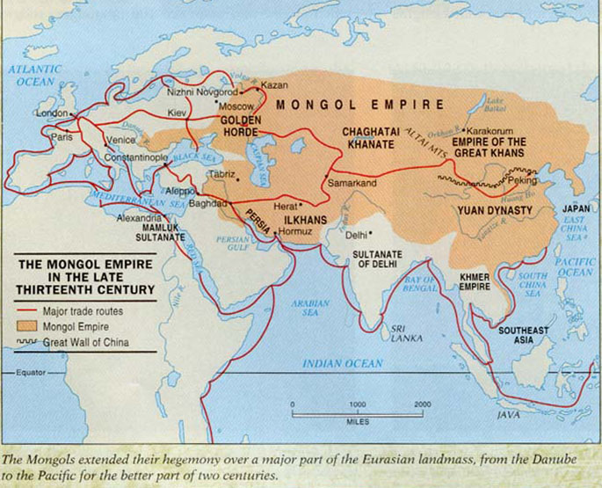

**Empire of the Great Khan**

**Throughout China’s long history, the Chinese feared and fought off invasions of northern nomads. Sometimes they lost territory but no foreigner had ever ruled the whole country. Kublai Khan was the first to do so.**

**Beginning a New Dynasty**

**Failure to Conquer Japan**

Explain the quote as it relates to Kublai Khan: “I have heard that one can conquer the empire on horseback, but one cannot govern it on horseback.”

The Mongols and the Chinese

**Encouragement of Foreign Trade:**

Marco Polo at the Mongol Court

The End of Mongol Rule

Yuan Dynasty Overthrown

Decline of the Mongol Empire

Explain what is meant by Kublai Khan straddled to worlds.

Why do some speculate that Marco Polo’s book might not be completely accurate?