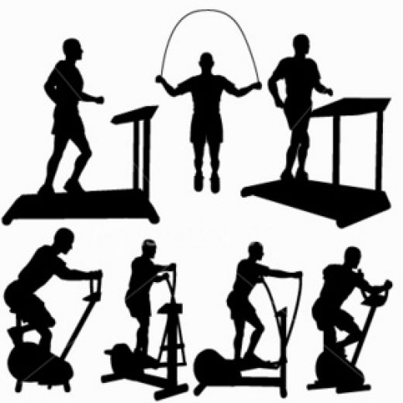Cardiovascular fitness is said to be the most important of all physical fitness components. No matter how strong you look, if your circulatory and respiratory systems cannot meet your muscles’ demand for oxygen, you cannot continue activity for a long period of time.

Exercising to improve cardiovascular fitness will increase your energy level, making it possible for you to exercise longer without tiring, and making you feel good. Additionally, exercising for cardiovascular fitness will help you look good; since the exercises will help you control your weight, improve your appearance, and improve your ability to meet the problems you face daily. You may be one of many people who have a low level of cardiovascular fitness if you find you are short of breath, tired easily, are unable to swim, run, bike or perform physical activities.

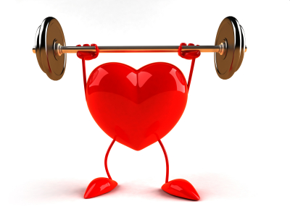Cardiovascular fitness is the body's ability to provide oxygen continuously to muscles as work is performed over an extended period of time. This component of fitness includes the circulatory system (Heart, blood, and blood vessels) and the respiratory system (lungs and air passages).

Research has shown that body functions improve with use and decline with disuse. In other words, the heart, lungs, and muscles become stronger and more efficient in the utilization of oxygen as they are used more. To understand how to improve your cardiovascular fitness, you must first understand how the circulatory and respiratory systems function and which diseases may result if the systems on neglected.