Name:____________________ Date:____________________

**Review Sheet Proportional Relationships Review Sheet**

1. Solve the following proportions.

= = =

1. Whitney earns $206.25 for 25 hours of work. How much does Whitney earn per hour?
2. At this rate, how much does Whitney earn in 30 hours?

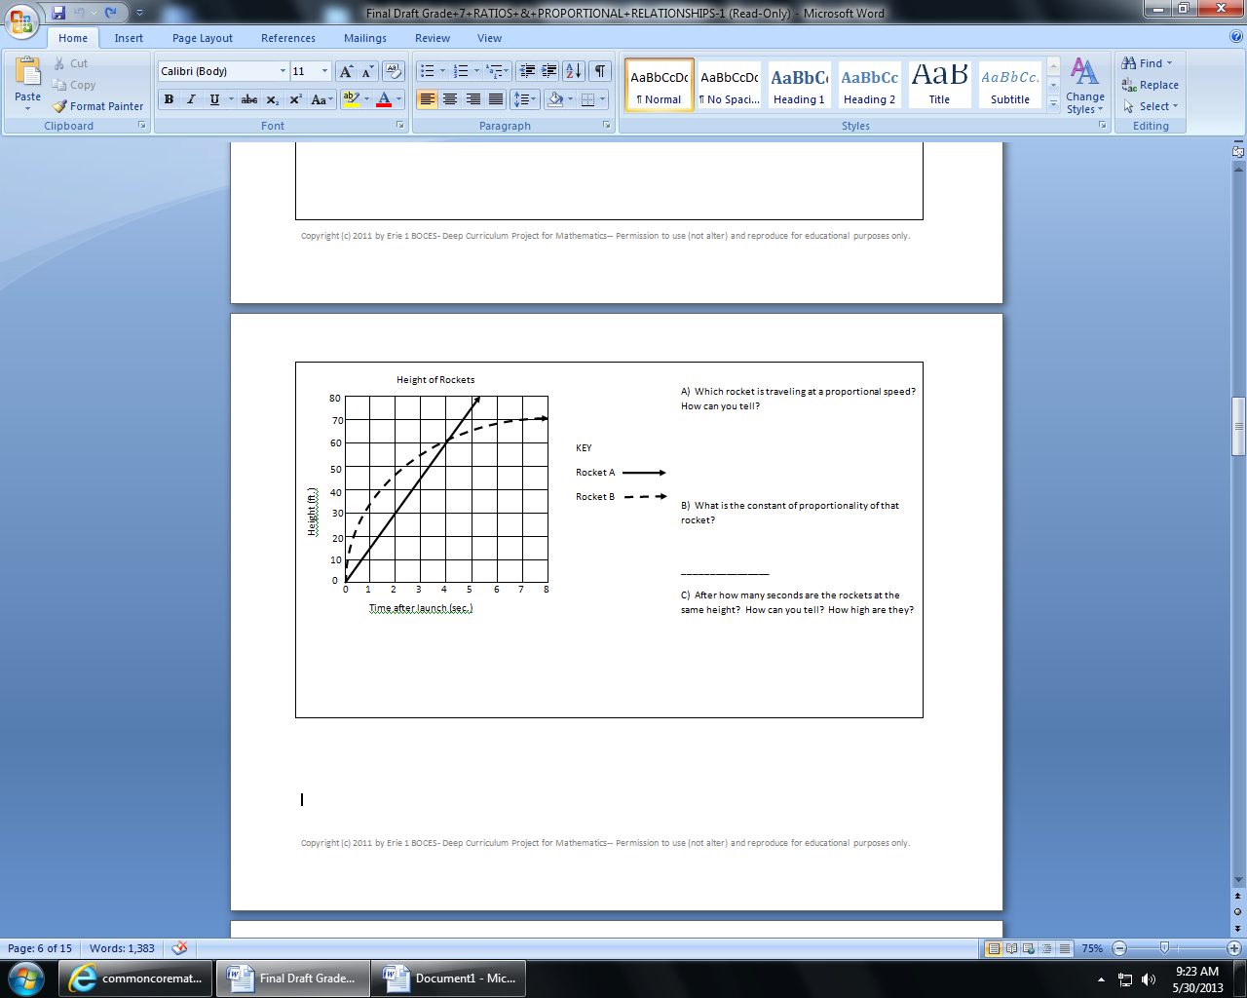

**3**.

**a)** Which rocket is traveling at a proportional speed?___________

**b)**How do you know ?

________________________

________________________

**c)** What is the constant of proportionality of that rocket?

**Determine whether the set of numbers in each table is proportional. If the table is proportional, determine the CONSTANT OF PROPORTIONALITY!**

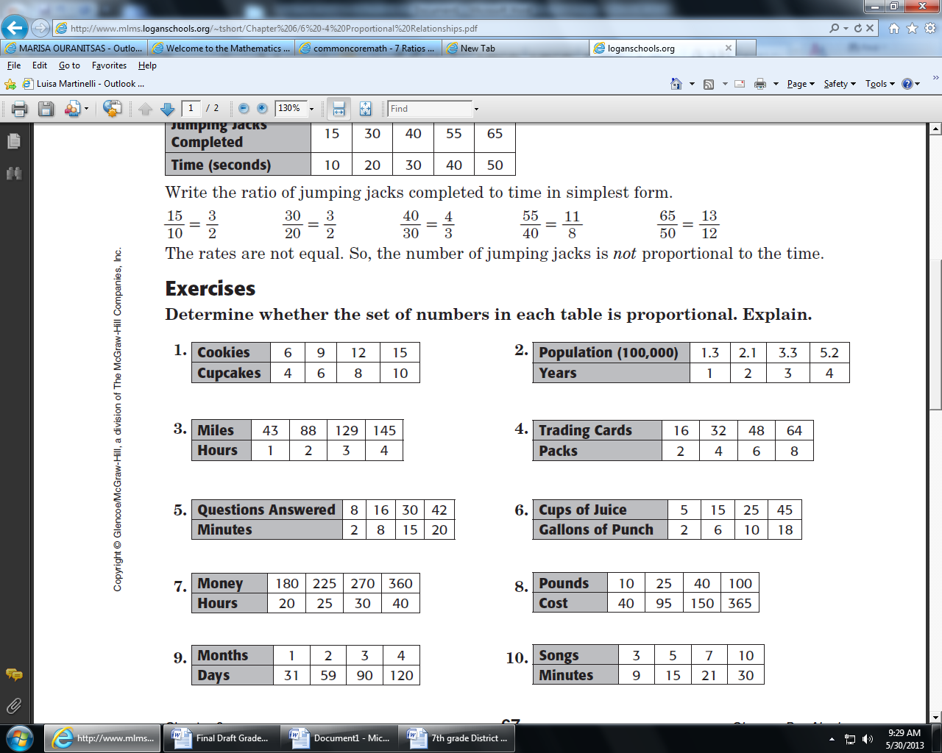

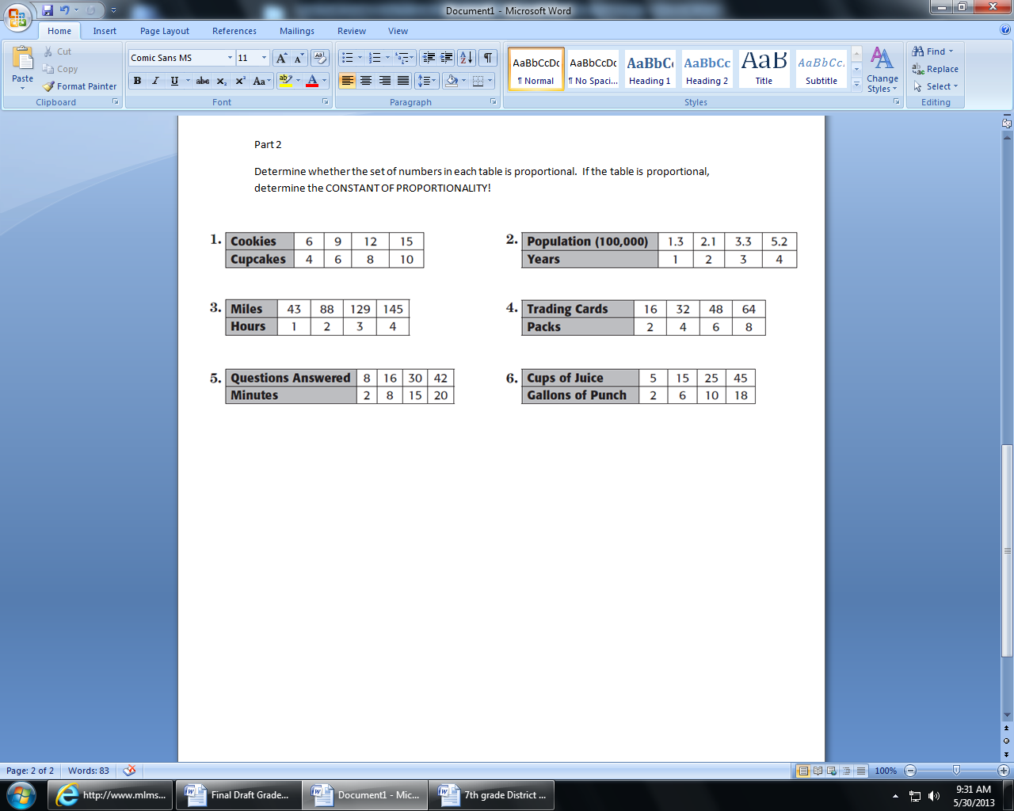

**5**. A grocery store has a 20% markup on bottle of soda.  The bottle of soda costs the store $1.25. Find the selling price. Round to nearest cent if necessary.

Markup=_________________ Selling Price =_______________

**6.** A pair of boots are $94.99.  They are 25% off. With this **discount**, what is the sale price? Round to nearest cent if necessary.

Markup=_________________ Selling Price =_______________

**7.** A 20-ounce box of cereal is priced at $3.80, and a 36-ounce box of the same cereal is priced at $6.45. Which box is the better buy and why**?**

Work:

Explain your reasoning:________________________________________________________________________________________________________________________________________________________________________________________________________________________________________________

**8.** A tree outside my house is 9 ft tall and has a shadow that is 12 ft long. If a bush nearby is 4 ft tall, how long is its shadow? (Hint: Draw a picture)

**9.** Are the following figures in proportion? If so, determine the scale factor between the following figures. (Hint: New over old)

