Directions: Your partner will watch you serve 5 times. If the cue is performed then check “can do”; if not check “needs practice”. Your performance need to be to the best of your ability and hit the target from a distance that is most challenging for you.
FORCE | Instructional Cue | Image |  | Attempt #
 | Starting position: Feet in stride position with left foot in front for right handed players. | 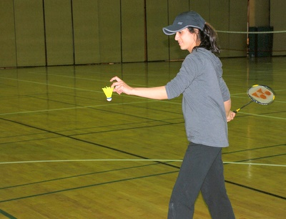 |  | #1 | #2 | #3 | #4 | #5
 |  |  | Can Do
 |  |  | Needs Practice
 | Body weight is shifted to the rear (back leg), then forward as racket comes forward. | 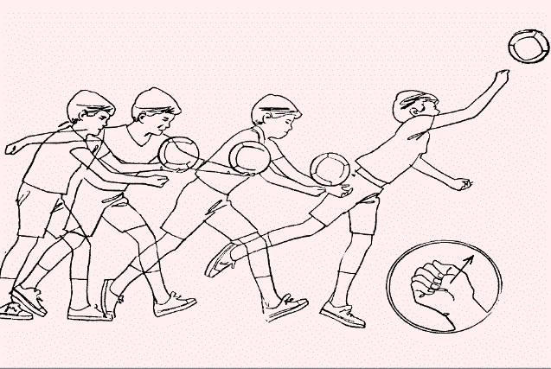 | Can Do
 |  |  | Needs Practice
MOMENTUM | Uses underhand serve. Shuttle contact is made well in front of the body, not at the side and is below the waist. | 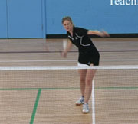 | Can Do
 |  |  | Needs Practice
 | Follow-Through: on the underhand stroke, the racquet carries over the left shoulder for right handed players. | 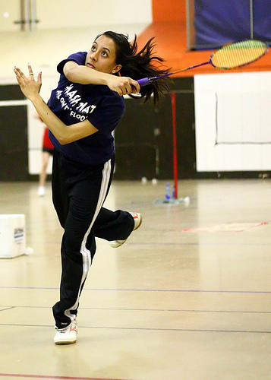 | Can Do
 |  |  | Needs Practice
 | Hit the Target Area | 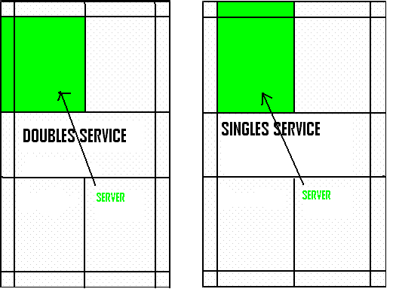 | Can Do
 |  |  | Needs Practice
After each person has made five serves, please identify one suggestion to improve their serving technique. Please list three positive comments about your partner’s serving technique.
List one suggestion to improve your partner’s serving technique:
#1:

List three positive comments about your partner’s serving technique. Please use instructional cues and science terminology:
#1:

#2:

#3:

